Introduction and Welcome

The Midlands District is delighted to welcome you to the Midlands District 2018 Masters Championship meet Information.

We would like to welcome you to our annual meet which is taking place at the Olympia Leisure Centre in Dundee. This competition venue includes electronic timing, and FINA registered starting blocks. There are over 200 seats in the stand which allows plenty of space for both spectators and competitors.

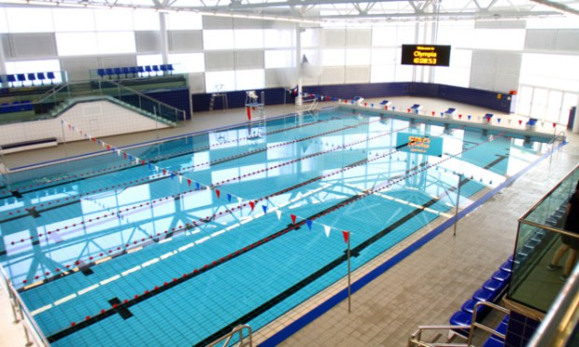

Dundee is easily accessible from all parts of the country and the pool is a stone’s throw from both rail and bus stations. There are ample hotels to suit any budget all within walking distance of Olympia.
At the conclusion of the swimming events, The Midlands District Masters invite all competitors and guests to attend the awards evening at the nearby RRS Discovery centre which will involve food, fun, awards and a chance for a catch-up with friends. The venue will allow stunning views of the new V&A museum

Thank you for supporting the Midlands District Masters and we look forward to welcoming you all to Dundee on 29thSeptember.

Meet Information

Date: Saturday 29 th September 2018
Venue: Olympia Leisure Centre, 3 East Whale Lane, Dundee DD13JU
Licence Number:MD/L2/023/Sept18

Individual events

Individual Medley |  | 100m | 200m
Freestyle | 50m | 100m | 200m
Butterfly | 50m | 100m | 200m
Backstroke | 50m | 100m | 200m
Breastroke | 50m | 100m | 200m
Skins | 25m

Individual Entry

Cost is £35 for up to 5 individual swims and the buffet
Each additional event is at a cost of £5 per entry
There is no additional cost to enter skins should you qualify.
Extra buffet tickets can be bought at £14

Visitor information
Please find link to venue below:

https://www.google.co.uk/url?sa=t&rct=j&q=&esrc=s&source=web&cd=1&cad=rja&uact=8&ved=0ahUKEwitpobt-8XVAhXFK1AKHVgUBoMQFggpMAA&url=http%3A%2F%2Fwww.rrsdiscovery.com%2F&usg=AFQjCNE_XyvqL6_mmB9S0DxVr-QFZDhAHg

SKINS

The Skins event at this inaugural meet will provide challenge and entertainment in equal measure!

There will be a Men’s and Women’s event, the lucky winners receiving prizes! Qualification to the ‘showdown’ will be through the ‘gateway’ event of the 100metres Individual Medley. (As such, there is no additional cost for the SKINS – the 100IM would form part of your initial entry fee for one of your five events)

- The fastest six males and females will qualify for their respective SKINS FINAL.
- The qualifiers will be spearheaded.
- Each race will consist of a 25m sprint.
- Each length will have a 2 minute turnaround.
- The stroke will be dictated by a ‘blind pick’ from a bag.
- The starter will ‘pick’ the first stroke of each final.
- The first start will be a conventional start (take your marks.)
- The last swimmer in each race will be eliminated.
- The eliminated swimmer will then ‘blind select’ the stroke that the following race will swim.
- Each race thereafter will be started by way of ’10 second warning’ by way of whistle, followed by starting beep for a go (no take your marks!)
- After 5 rounds the person ‘still standing’ is the winner.

Judges word is final!

Whilst the 100IM will form part of any cumulative scores for age group awards, the FINAL will not draw any additional points – ITS FOR FUN!

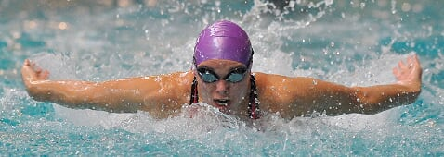
Age groups

Y 16-17 F 50-54
X 18-24 G 55-59
A 25-29 H 60-64
B 30-34 I 65-69
C 35-39 J 70-74
D 40-44 K 75-79
E 45-49 L 80+

CLOSING DATE FOR ENTRIES 12 NOON, 16tH SEPTEMBER 2018
(Late entries may not be accepted)

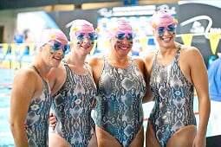

MEET PROGRAMME

WARM UP 1130

SESSION 1
101 MIXED 100M INDIVIDUAL MEDLEY
102 MIXED 50M BREASTSTROKE
103 MIXED 100M BUTTERFLY
104 MIXED 200M BACKSTROKE
105 MIXED 50M FREESTYLE
106 MIXED 100M BREASTROKE
107 MIXED 200M BUTTERFLY
108 SKINS
30 min break if programme allows

SESSION 2
201 MIXED 200M FREESTYLE
202 MIXED 100M BACKSTROKE
203 MIXED 50M BUTTERFLY
204 MIXED 200M BREASTROKE
205 MIXED 50M BACKSTROKE
206 MIXED 200M INDIVIDUAL MEDLEY
207 MIXED 100M FREESTYLE
208 ALLSTARS 4X50M FREESTYLE RELAY

Meet rules
All competitors must be a member of SASA /ASA in line with FINA rules .All entrants should be 16 at the end of December 2018.Dependant on number of entries received , the organisers reserve the right to introduce over the top starts and / or adjust the start time of the session. All event s are heat declared winners in each age classification. In each event swimmers will be seeded according to their entry time and will compete against those with similar times regardless of age or gender.

Scoring
The following points will be awarded for individual placings

 |  | INDIVIDUAL POINTS
1st | 2nd | 3rd | 4th | 5th | 6th
6 | 5 | 4 | 3 | 2 | 1

Results

Results will be posted as soon as they are available on poolside and in spectator’s gallery

Awards

Medals will be awarded to the top three in age group for each race and an overall prize for each age group winners.
Skins events are not categorized into age groups, prizes will be awarded to top six in both male and female events.

All medals and skins prizes can be collected at the pool during the event. Age group prizes will be awarded at the award ceremony championships.

MIDLANDS DISTRICT.

COMPETITOR SAFETY CODE

IT IS IMPORTANT THAT ALL COMPETITORS READ THE FOLLOWING BEFORE SIGNING THE RELATED ENTRY FORM.THE SIGNING AND SUBMISSION OF ENTRY FORM CONFIRMS THAT THE COMPETITOR HAS READ, UNDERSTOOD AND AGREES TO ABIDE BY THE CODE.
1. ALL COMPETITORS SHOULD SEEK APPROPRIATE ADVICE IF THEY HAVE ANY CONCERNS AS TO THE STATE OF THEIR HEALTH.THEY HAVE NOT BEEN INFORMED BY THEIR MEDICAL PRACTIONNER THAT THEY HAVE ANY MEDICAL CONDITION THAT WOULD MAKE IT INADVISABLE TO PARTICIPATE IN MASTERS SWIMMING EVENTS OR OTHER ASSOCIATED ACTIVITIES.THUS ASSUMING THE COMPETITOR IS PHYSICALLY FIT AND WELL TO PARTICIPATE IN SUCH EVENT.
2. COMPETITORS SHOULD BE APPRECIATIVE OF THE RISKS INVOLVED IN SAID COMPETITION INCLUDING THE POSSIBILITY OF INJURY AND ACCIDENT.COMPETITORS SHOULD AGREE TO CONDUCT THEMSELVES IN A RESPONSIBLE AND PROFESSIONAL MANNER.
3. COMPETITORS SHOULD UNDERTAKE AT ALL TIMES TO USE THEIR BEST ENDEAVOURS TO TRAIN AND COMPETE IN A SAFE AND PROPER MANNER AND NOT TO DO ANYTHING THAT WOULD EXPOSE THEMSELVES OR OTHER SWIMMERS UNNECESSARY RISK OF INJURY
4. COMPETITORS SHOULD UNDERTAKE AT ALL TIMES TO TAKE REASONABLE SAFETY MEASURES FOR THE PROTECTION OF THEMSELVES AND FELLOW SWIMMERS AND TO INFORM THE REFEREE OF ANY CONCERNS THEY HAVE WITH REGARDS TO SAFETY
5. COMPETITORS SHOULD ACKNOWLEDGE THAT DURING MASTERS SWIMMING EVENTS MIDLANDS DISTRICT AND DCA CANNOT BE HELD RESPONSIBLE FOR ANY LOSS OR DAMAGE TO PERSONAL BELONGINGS AND THAT THE COMPETITOR SHOULD TAKE ALL REASONABLE STEPS AGAINST SUCH LOSS OR DAMAGE
6. COMPETITORS ACCEPT AND ABIDE, AND BE GOVERNED BY THE RULES OF SCOTTISH SWIMMING AND ALL OTHER LAWS AND REGULATIONS APPLICABLE INCLUDING SASA SAFETY LAWS AND THE CONDITIONS OF THE SASA MIDLANDS DISTRICT.

ENTRY FORM

FULL NAME:

ADDRESS:

DOB:

AGE CAT:

GENDER: M/F

CLUB:

SASA REG NO.

CONTACT NO.

EMAIL:
Time should be entered as mm:ss:hh
STROKE | 50M | 100M | 200M | SKINS
INDIVIDUAL
MEDLEY
FREESTYLE
BUTTERFLY
BACKSTROKE
BREASTSTROKE
All Stars 50 free time will be required to allow participation in the relay.

I AM ATTENDING AWARDS AFTERWARDS: Y/N

Please note any dietary requirements that you may have:

Item | Cost
Entry fee (5 events + awards) | £35.00
Additional events £ 5.00 each
Additional awards ticket for visitors etc. £14
Total Cost

Entry forms to be sent to: Claire Murray 36 Lochbank Gardens, Forfar, DD83HG or via email to clairemurraywilliams@hotmail.co.uk
Entries to be paid:
via PAYPAL to midlandsdistrict@gmail.com or
directly online to Account no: 00760821 and Sort code: 835000
Please put your name as reference and email confirmation of payment to clairemurraywilliams@hotmail.co.uk
In submitting this form I declare that the above information is correct and that I have read understood and agree to abide by the conditions of the swim meet as outlined in the information pack.

Signed: Date:
£5
£6
£12

